

# Team 24 – Sprint 1 Testing Document

Sakshi Choudhary, Giorgi Khmaladze, Nick Litman, Mihir Somani, Conley Utz

# User Story #1

**Test 1: Given that they have already registered, a user is trying to log in.**

Purpose: To meet the acceptance criteria the user must provide correct email and password for logging in.

Steps:

1. Given that a session has not been started yet, the user chooses to enter the index/login page of the website. 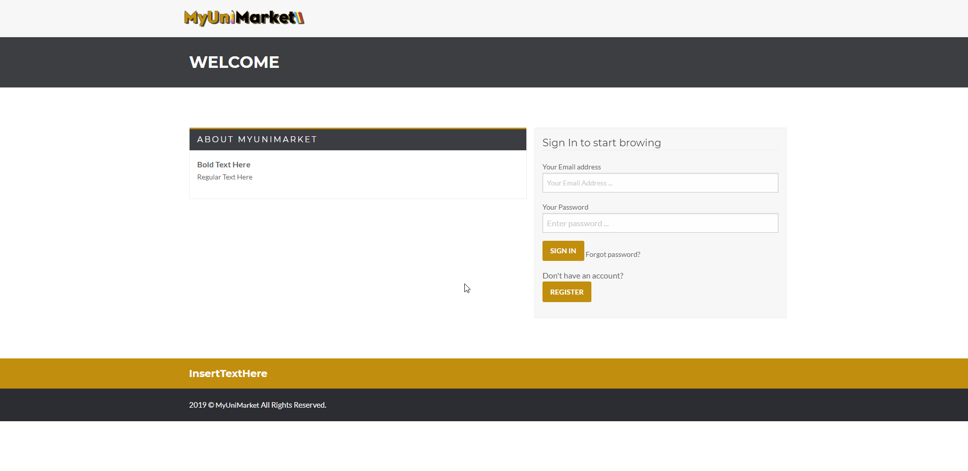
2. The user enters their login information. 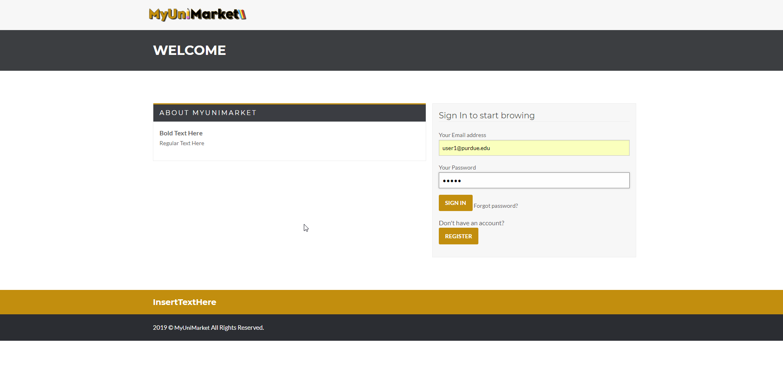
3. The user clicks log “SIGN IN” 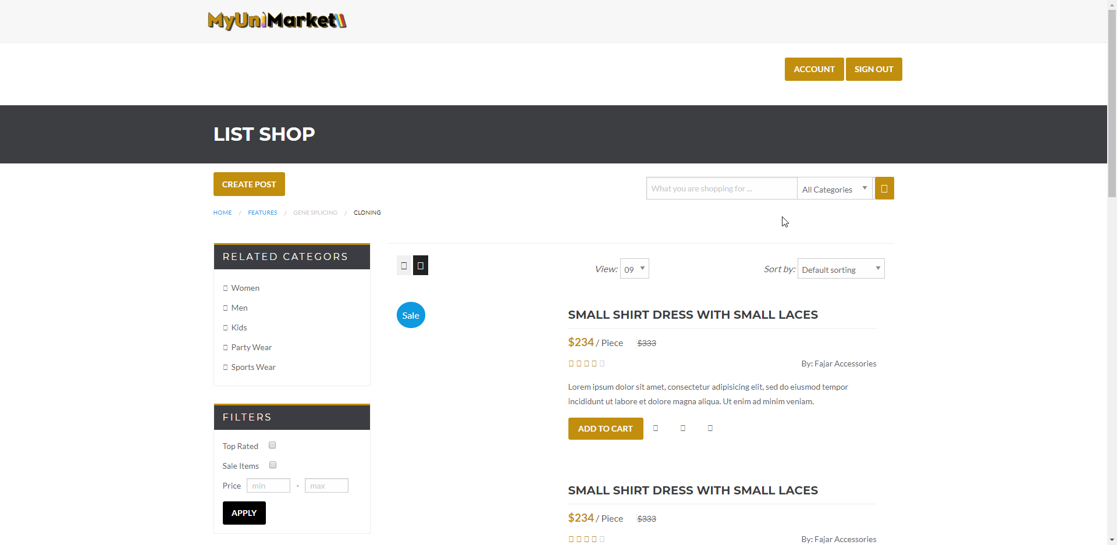

Expected result: The user is redirected to the main market page.

Test Result: **PASSED**

**Test 2: A user is trying to sign in without entering any information.**

Purpose: To meet the acceptance criteria, the user must complete all required fields (email and password in this case.)

Steps:

1. The user enters the sign in page. 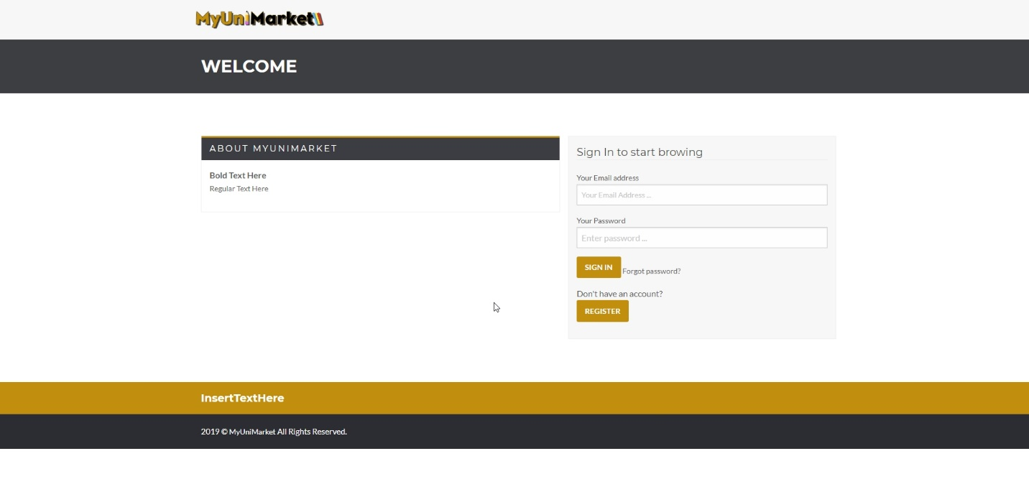
2. The user clicks “SIGN IN” without entering any information. 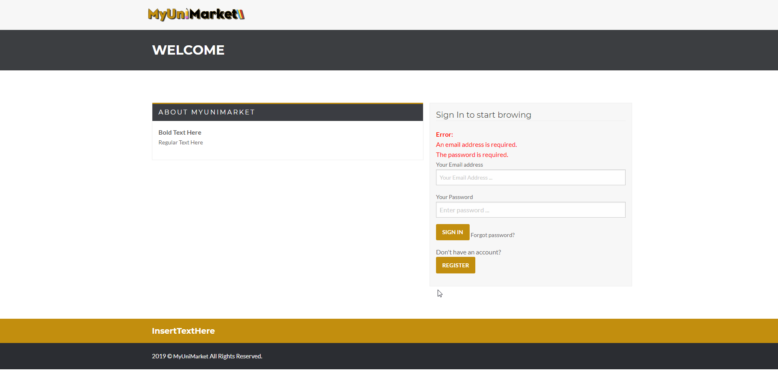

Expected Result: The browser must notify the user that they have not completed certain required fields.

Test Result: **PASSED**

**Test 3: A user is trying to sign in without entering a password.**

Purpose: To meet the acceptance criteria, the user must complete all required fields (email and password in this case.)

Steps:

1. The user enters the sign in page. 
2. The user provides only the email address. 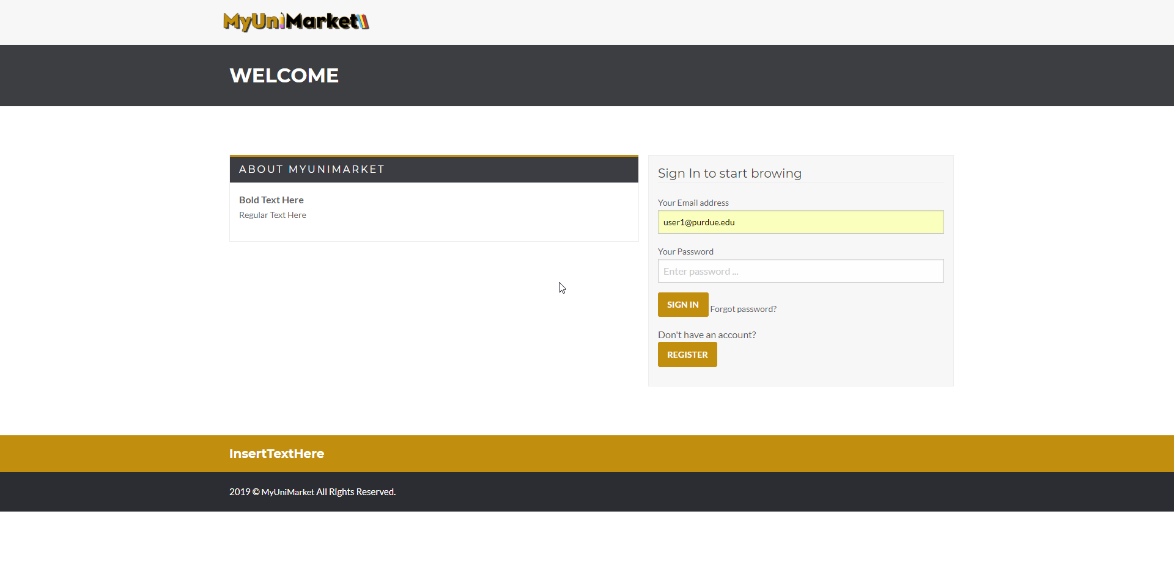
3. The user clicks “SIGN IN”. 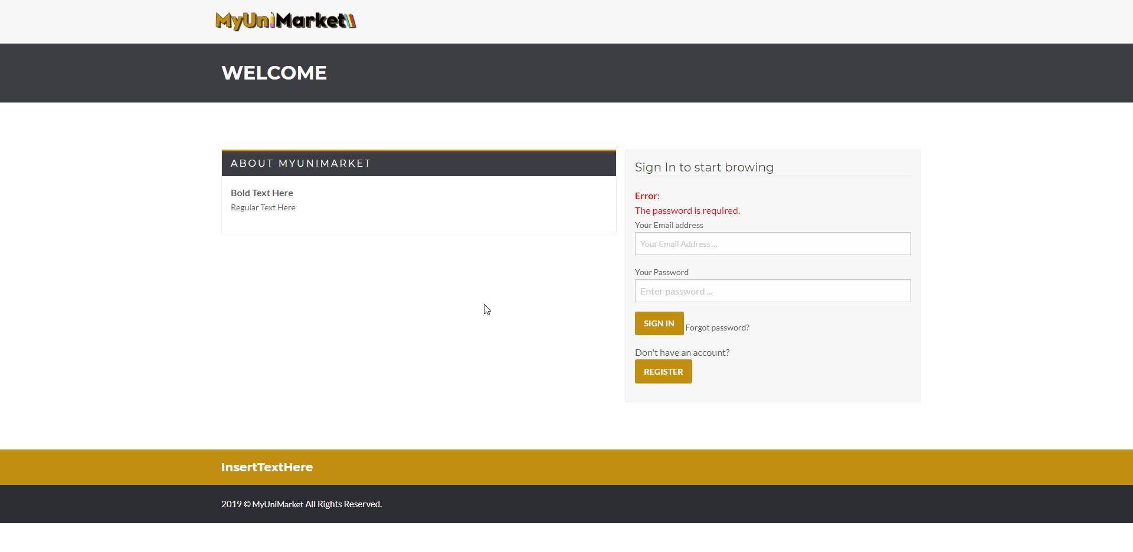

Expected Result: The page notifies the user that they have not enter their password.

Test Result: **PASSED**

**Test 4: A user is trying to sign in with an invalid email format.**

Purpose: To meet the acceptance criteria the page must notify the user that their email format is invalid.

Steps:

1. The user enters the sign in page. 
2. The user provides mistyped/invalid format email. 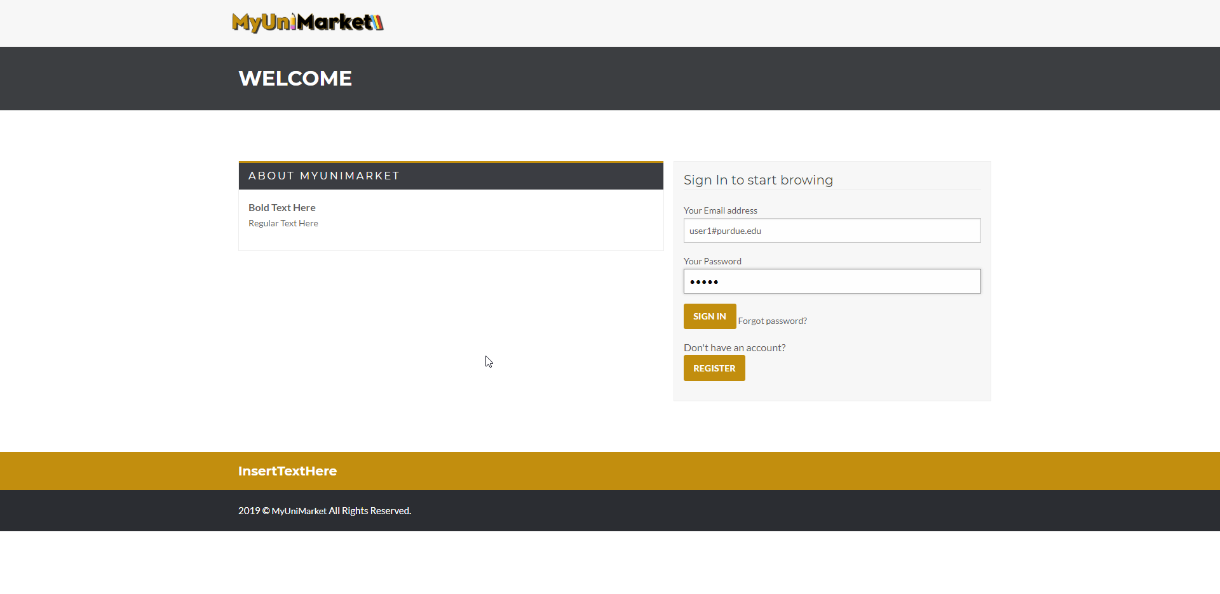
3. The user clicks “SIGN IN”. 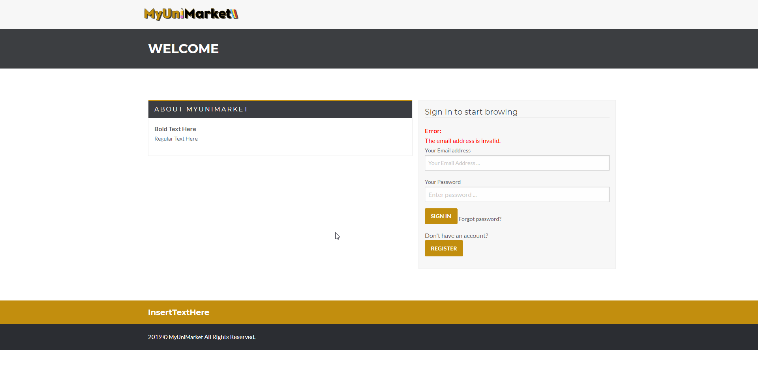

Expected Result: The user must be notified that they have mistyped or used an invalid syntax for their email address.

Test Result: **PASSED**